UI Info for Untitled Cat game.

Elements needed:-

* AP counter, needs to show the amount each turn dropping down as player makes there moves, also needs to reset each turn.
* In game Unit counter, shows number of units on the board
* Number of unit reinforcements left, shows the number of units still to be summoned, should also have a locked out element if the player already has the max number of units in the on the game board (ie the max number of units aloud on the board is 10, so if the player had 4 units left to summon but has 10 on the board then the UI element should be locked out.) or has spent all there reinforcements. You could have wool come across it like a ball of wool or something.
* A carboard box counter see above.
* A Game option menu. Ideally with the following options.
  + Resign
  + Sound
  + Game options (like screen resulation, graphic options…. Etc)

The start menu needs the same but also……

* A Quit game option
* Single player (if we have that)
* Board size (if we have that)
* Tutorial (if we have that)
* Difficulty (if we have a single player option)

I think that’s Everything.

Here are a few IU ideas.

UI 1 Mario.

UI 2 Fortnite.

UI 3 Mario v Rabits.

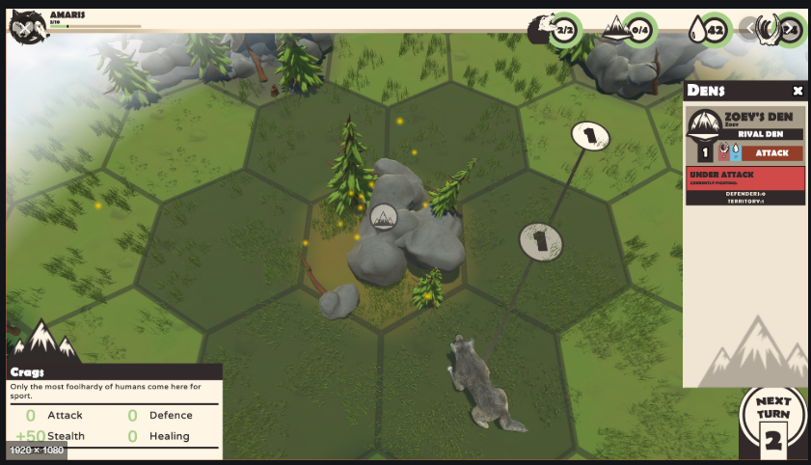

UI 4 Unknown Game.

UI 5 Unknown Game.

UI 6 Unknown Game.